STATESBORO-BULLOCH COUNTY AIRPORT
STANDARD OPERATING PROCEDURES
Table of Contents
Section One – Airport Committee
1.01 Public Body
1.02 Airport Committee
1.03 Airport Manager
Section Two - Purpose and Scope of Standard Operating Procedures
2.01 Purpose
2.02 Scope
2.03 Conflicts
2.04 Effective Date
2.05 Amendments
2.06 Notice to Public
2.07 Distribution
Section Three - Definitions
3.01 Airport
3.02 Air Operations Area
3.03 Air Traffic Area
3.04 FAA
3.05 Persons
3.06 Ramp Area
3.07 Other Terms
Section Four - General Standard Operating Procedures
4.01 Restrictions on Use of Air Operations Area
4.02 Solicitation of Funds
4.03 Signs, Advertisements, Circulation of Printed Matter
4.04 Travel Areas
4.05 Animals
4.06 Personal Property
4.07 Disorderly or Indecent Conduct
4.08 Prohibition Against Gambling
4.09 Disposal of Trash
4.10 Destruction of Property
4.11 Damage to Persons or Property
4.12 Registration of Aircraft
Section Five - Motor Vehicle Operations
5.01 Permitted Vehicles
5.02 Vehicle Operators Permits
5.03 Vehicles Permitted in Air Operations Areas
5.04 Two-Way Radio Requirements
5.05 Vehicle Requirements for entry into Air Operations area or Ramp Area
5.06 Vehicle Speed
5.07 Vehicle Parking
5.08 Driving Under the Influence
Section Six - Aircraft Fueling and Defueling
6.01 Right to Sell and Dispense Aviation Fuel
6.02 Disposition of Aviation Fuels, Lubricants, Chemicals iii
6.03 Fueling or Defueling of Aircraft Fuel Tanks
6.04 Transportation and Storage of Flammable Materials
Section Seven - Aircraft Operations
7.01 General Conduct of Aeronautical Activities
7.02 Airport Manager
7.03 Aircraft Taxi Control
7.04 Aircraft Taxi Speeds
7.05 Takeoff and Landing
7.06 Standard Traffic Pattern Procedures
7.07 Restrictions on Aircraft Start-up
7.08 Restriction on Engine run-up
7.09 Prohibitions on Smoking
7.10 Disposition of Aircraft Parts
Section Eight - Tie Down Areas
8.01 Pilot Responsibility
8.02 Supplying of Ropes
8.03 Defects
8.04 Aircraft Maintenance
Section Nine - T-Hangars
9.01 Use of T-Hangar Buildings
9.02 Storage in Hangars
9.03 Use of Engine Pre-Heaters/Space Heaters
9.04 Building Discrepancies
Section Ten - Fire Prevention and Safety
10.01 General Conduct
10.02 Compliance with Fire Prevention Signs
10.03 Storage of Waste or Debris
10.04 Cleaning of Aircraft Parts
10.05 Storage of Flammable Liquids
10.06 Removal of Flammable Containers
10.07 Care of Hangar Floors
Section Eleven - Penalties for Failure to Comply with Standard Operating Procedures
11.01 Failure to Comply with Standard Operating Procedures or Directions of Airport Personnel
11.02 Deviations from Standard Operating Procedures
11.03 Termination of Lease
11.04 Civil Remedy or Criminal Prosecution

SECTION ONE - COMMITTEE
1.01 Public Body: The Statesboro-Bulloch County Airport (the "Airport") is situated in Bulloch County, Georgia. The Airport is jointly owned by Bulloch County and the City of Statesboro and operated by Bulloch County. The Airport is subject to compliance with Bulloch County's purchasing policy and other policies as applicable. Leases and contracts are subject to approval by the Bulloch County Board of Commissioners (the “Board of Commissioners”). If the contract or lease would affect the City of Statesboro's property interest in the Airport, it may be approved by the Mayor and City Council if necessary.
1.02 Airport Committee: The Statesboro-Bulloch County Airport Committee (the “Airport Committee”) is responsible for the day-to-day operation, maintenance, and capital improvements to the Airport. The Airport Committee is composed of not less than eight (8) nor more than (12) members, as designated by the Board of Commissioners. The Airport office is located at 601 Airport Blvd. Statesboro, GA 30461.
1.03 Airport Manager: The daily operations of the Airport are under the direction and control of the Airport Manager, who is an employee of Bulloch County.
SECTION TWO - PURPOSE AND SCOPE OF STANDARD OPERATING PROCEDURES
2.01 Purpose:
The Airport Committee and the Board of Commissioners have adopted these Standard Operating Procedures to provide for the protection, welfare, and safety of all persons using the Airport, including members of the public and employees of users or lessees of Airport facilities, and their property.
2.02 Scope:
These Standard Operating Procedures will govern the conduct of all persons upon or near the Airport while engaged in aeronautical, vehicular or pedestrian activities at the Airport, or while flying within the boundaries of the Airport Traffic Area, other than such conduct or activity specifically regulated or controlled by federal or state statutes or regulations, or unless exceptions to these Standard Operating Procedures are authorized in writing by the Airport Manager.
2.03 Conflicts:
These Standard Operating Procedures will govern the conduct of all persons and the use of all property situated on the Airport or in the Airport Traffic Area to the extent permissible by law. These Standard Operating Procedures are believed to conform with all applicable federal and state statutes, as well as FAA regulations and directives. However, in the event of any conflict with these Standard Operating Procedures, such laws, regulations, and directives shall control and supersede.
In the event of any conflict in the effect or operation of any provision of these Standard Operating Procedures with any provision of a lease or agreement between the County and other parties, the provision imposing the greater obligation on the other party and/or providing the greater benefit to the County shall prevail. If there is any dispute about which provision prevails, the matter shall be referred to the Airport Manager for interpretation. In the event the Airport Manager is unable to resolve the issue satisfactorily, it shall be referred to the Airport Committee for resolution, and the decision of the Airport Committee shall be final and binding and not subject to any appeal.
2.04 Effective Date: These Standard Operating Procedures, and any amendments adopted thereto, shall be effective as of the date of final approval by the Board of Commissioners, unless otherwise specified in the adopting resolution, and shall supersede all conflicting Standard Operating Procedures, if any, previously in effect.
2.05 Amendments: The Airport Committee and the Board of Commissioners reserve the right to amend, modify, rescind, or change, in any manner whatsoever, any Standard Operating Procedure without prior notice to the public or any other persons.
2.06 Notice to Public: The complete text of all Standard Operating Procedures adopted by the Board of Commissioners shall be maintained at the principal offices of the Airport, and shall be available during business hours for inspection and copying by any member of the public. Public notice of the existence of these Standard Operating Procedures and of the right to review shall be posted prominently in at least one (1) or more locations accessible to the general public at the Airport.
2.07 Distribution: Copies of these Standard Operating Procedures may be provided to those persons using the facilities of the Airport as an air carrier, fixed-base operator, lessee, franchisee, common surface carrier, or other authorized user of the Airport. Recipients may be charged for the cost of reproduction, such charge to be waived at the discretion of the Airport Manager.
SECTION THREE - DEFINITIONS
3.01 Airport: “Airport” means the entire real property owned, leased or under the control of the Statesboro-Bulloch County Airport, whether or not such property is contiguous to the principal portion of the Airport, together with the applicable approach surfaces lying over such real property, situated in the Bulloch County, Georgia.
3.02 Air Operations Area or AOA: “Air Operations Area” or “AOA” means all Airport areas where aircraft can operate, either under power or while in tow. The AOA includes runways, taxiways, and areas shown in green on Exhibit A. (AC150/5220 – 24)
3.03 Air Traffic Area: “Air Traffic Area” means area on an airport surface or in the air above the airport.
3.03 FAA: “FAA” means the Federal Aviation Administration.
3.04 Person: “Person” means any individual, firm, partnership, corporation, company, association, or other legal entity.
3.05 Ramp Area: “Ramp Area” means the area shown in blue on Exhibits A and B.
3.06 Other Terms: All terms defined in FAA regulations or directives, if applicable to operations conducted at the Statesboro-Bulloch County Airport, are included herein by reference.
SECTION FOUR - GENERAL
4.01 Restrictions on Use of Air Operations Area: No person or persons, except airmen, duly authorized personnel, passengers going to or from aircraft, or others personally escorted by airmen or Airport attendants shall be permitted to enter the Air Operations Area. This does not give any person or persons so authorized the right to unrestricted use of the AOA. These privileges are confined to the necessary use of the Air Operations Area in connection with flights, inspections, or routine duties. The privileges may be revoked by the Airport Manager when, in the Airport Manager's opinion, such action is necessary for the safety of the public or the safe and efficient operation of the Airport.
4.02 Solicitation of Funds: No person shall solicit funds for any purpose, or offer any merchandise or services for sale, on or at the Airport without the permission of the Airport Manager.
4.03 Signs, Advertisements, Circulation of Printed Matter: No person shall post, distribute or display signs, advertisements, circulars, printed or written material at the Airport except with the approval of the Airport Manager and in such manner as may be prescribed.
4.04 Travel Areas: No person shall:
A. Traverse on Airport property other than on roads, walks, or places provided for the particular class of traffic, other than emergency or service vehicles.
B. Use the roads or walks in such a manner as to hinder or obstruct their proper use.
4.05 Animals: No person shall enter the Airport property with a dog, cat, bird, or any other animal, including a "seeing eye or ear" dog or emotional support animal, unless such animal is controlled in a suitable manner, i.e. confined to a vehicle or contained by a leash or other manner.
4.06 Personal Property:
A. No person shall abandon any personal property at the Airport. Property that is deemed to be abandoned at the Airport shall be disposed of in the manner prescribed by law.
B. Any person finding any lost article shall refer the item to the Airport office.
4.07 Disorderly or Indecent Conduct: No person shall commit any disorderly, obscene, indecent, or unlawful act or commit any public nuisance upon the Airport.
4.08 Prohibition Against Gambling: No person shall conduct any gambling in any form or operate gambling devices anywhere at the Airport.
4.9 Disposal of Trash: No person shall dispose of trash, garbage, paper, junk, debris, or other refuse or materials at or on the Airport except in containers and at locations provided for that purpose. Disposal of old furniture, appliances, building materials, or carpet in any area of the Airport is strictly prohibited.
4.10 Destruction of Property: No person shall destroy, damage, or disturb in any way any building, sign, equipment, marker, or other structure, tree, flower, lawn, or other public property at the Airport. Any person so doing, either by accident or intent, shall be liable to Bulloch County for the reasonable value of the property so damaged or destroyed.
4.11 Damage to Persons or Property: Neither Bulloch County, the City of Statesboro, nor any of their officials, officers, or employees assumes any liability for loss, injury, or property damage to persons or property on the Airport or using Airport facilities because of fire, theft, vandalism, wind, flood, earthquake, collision or other acts beyond their control.
4.12 Registration of Aircraft: All aircraft, other than experimental or project aircraft, that are hangared, parked, or remaining on or at the Airport permanently shall be registered with the Airport office giving the owners’ names, addresses, phone numbers (permanent and local), aircraft type, aircraft registration number, and location of aircraft at the Statesboro-Bulloch County Airport. For purposes of this section, the term “permanently” shall mean any evidence or intention to hangar, park, or maintain an aircraft on or at the Airport for more than six (6) months.
SECTION FIVE - MOTOR VEHICLE OPERATIONS (AC 150/5210-20A 3 pages 1-5) https://www.faa.gov/documentLibrary/media/Advisory_Circular/150-5210-20A.pdf
5.01 Permitted Vehicles: Only vehicles necessary to the operation of the Airport, vehicles operated by duly authorized personnel, vehicles carrying passengers going to or from aircraft, or vehicles personally escorted by airmen or Airport attendants shall be permitted to enter the Air Operations Area (green area on Exhibit A). This does not give any person or persons so authorized the right to unrestricted use of the AOA. These privileges are confined to the necessary use of the Air Operations Area in connection with flights, inspections, or routine duties. The privileges may be revoked by the Airport Manager when, in the Airport Manager's opinion, such action is necessary for the safety of the public or the safe and efficient operation of the Airport.
5.02 Vehicle Operator Permits: Operators of vehicles needing access to the Air Operations Area of the Airport must request permission from the Airport staff. Authorized vehicle operators will be issued a permit in a form to be determined by the Airport Manager.
5.03 Vehicles Permitted in Air Operations Area: Subject to meeting all other requirements in this Section 5, vehicles eligible to use the Air Operations Area shall include, but not be limited to, maintenance vehicles, utility vehicles, automobiles, trucks, ambulances, hearses, buses, construction equipment, aircraft tugs, and mobile fuel trucks. Motor homes, bicycles, motorcycles, snowmobiles, motor scooters, and all other off-road vehicles shall not be permitted such use.
5.04 Two-Way Radio Requirements: Any vehicles, as a condition for the use of the Air Operations Area, must be equipped with a functioning two-way radio capable of communication on the Airport UNICOM frequency. A hand-held radio will be acceptable.
5.05 Vehicle Requirements for Ramp Area and Air Operations Area: Vehicles requiring entrance to the Air Operations Area and Ramp Area shall be equipped with a functioning flashing or rotating amber beacon mounted upon the highest part of the vehicle, or have operational emergency flashers. The beacon or emergency flashers must be in operation at any time the vehicle is in those areas of the Airport. A three-foot square flag consisting of nine squares of alternate aviation orange and white may be substituted for the beacon or flashers.
5.06 Vehicle Speed: With the exception of vehicles belonging to the Airport and operated by Airport personnel, and emergency vehicles such as ambulances or fire trucks, no vehicle shall exceed fifteen (15) miles per hour in the Airport Operations Area and Ramp Area.
5.07 Vehicle Parking: Vehicles shall not be parked at the Airport in any manner or at any location prohibited by traffic signs, markings, or other means. No vehicle that is inoperable or has expired tags shall be parked at the Airport.
5.08 Driving under the Influence: No person shall operate any vehicle or other mechanized equipment upon the Airport while under the influence of alcohol, narcotics, or other drugs, with the exception of drugs taken in accordance with a lawful prescription from a medical doctor that do not affect the ability to safely operate such vehicles.
SECTION SIX - AIRCRAFT FUELING AND DEFUELING
6.01 Right to Sell and Dispense Aviation Fuel: Other than self-fueling, the Airport reserves the exclusive right to sell or dispense aviation fuel.
6.02 Disposition of Aviation Fuels, Lubricants, Chemicals: No aviation fuels, lubricants, oils, greases, chemicals, or other harmful or hazardous liquids or materials shall be drained onto or deposited on any Airport surface. Aviation fuels sumped from an aircraft as part of a preflight inspection shall be contained and dispersed in a suitable manner, not on the grass areas.
6.03 Fueling or Defueling of Aircraft Fuel Tanks: Except for trained and certified aircraft mechanics performing fuel tank maintenance per all applicable laws and regulations, no aircraft fuel tank shall be fueled or defueled in any building or structure upon or at the Airport.
6.04 Transportation and Storage of Flammable Materials: No fuel or other flammable material shall be transported into or upon the Airport in any unapproved container, and no fuel or other flammable substance shall be stored in any building except in an approved area.
SECTION SEVEN - AIRCRAFT OPERATIONS
7.01 General Conduct of Aeronautical Activities: All aeronautical activities at the Airport and all aircraft arriving at or departing from the Airport shall be conducted in conformity with the current provisions of the Federal Aviation Regulations and Airman's Information Manual as issued by the Federal Aviation Administration and the laws of the State of Georgia.
7.02 Airport Manager: The Airport Manager shall, at all times, have the authority to take such action to protect and safeguard all persons and property and to control operations or any other activity at the Airport as may be necessary.
The Airport Manager, either directly or through an authorized representative, may suspend or restrict any or all aircraft operations without regard to weather conditions, whenever such action is deemed necessary in the interest of safety.
7.03 Aircraft Taxi Control: Pilots will taxi their aircraft onto the Air Operations Area only after they have determined they will not be a hazard to other aircraft.
7.04 Aircraft Taxi Speeds: At all times, aircraft will taxi at a safe and reasonable speed and with due regard for other aircraft, persons, and property.
7.05 Takeoff and Landing: Takeoffs and landings shall be made only on designated runways. Aircraft shall not take off from or land upon the grass areas of the Airport except as authorized by the Airport Manager or in cases of emergency.

7.06 Standard Pattern Procedures: The following rules shall apply to aircraft in the airport traffic pattern:
A. A standard left-hand traffic pattern shall be used for traffic landing in either direction.
B. Pilots shall comply with the appropriate sections of FAR Part 91(B) and the Airman’s Information Manual.
7.07 Restrictions on Aircraft Start-up: When the engine is operating, the aircraft shall be properly secured or have a qualified pilot or mechanic at the controls of all aircraft. If it is necessary to hand prop an aircraft, the aircraft should be tied down or chocked. Under no circumstances shall an aircraft engine be started or allowed to run with the aircraft unsecured or with no one at the controls.
7.08 Restriction on Engine Run-up: Short maintenance run-ups shall be permitted on the main ramp.
7.09 Prohibitions on Smoking: Smoking shall be prohibited:
A. In any place where smoking is prohibited explicitly by signs.
B. Within twenty-five (25) feet of any fuel tanks or fuel truck not in motion.
C. Within fifty (50) feet of any fueling operation in progress.
D. In any area where prohibited by federal or state laws or regulations or any other competent regulatory authority.
7.10 Disposition of Aircraft Parts: The aircraft owner shall be responsible for the prompt disposal of any wrecked aircraft or aircraft parts. In the event Airport personnel must remove such aircraft or aircraft parts for the good of the Airport, such removal shall be at the owner's expense and without liability for damage which may result in the course of such removal.
SECTION EIGHT - TIE DOWN AREAS
8.01 Pilot Responsibility: Each pilot is responsible for securing his/her aircraft.
8.02 Supplying of Ropes: Pilots are strongly encouraged to supply their own tie-down ropes. The Airport is not responsible for any damage caused by the use/failure of ropes provided by the Airport.
8.03 Defects: Airport personnel shall be immediately notified of any problems or defects associated with tie-down space.
8.04 Aircraft Maintenance: Minor aircraft maintenance is permitted in the tie-down areas. Aircraft operators shall be allowed to perform minor repairs that do not require the use of open flame, highly heated parts (except for a soldering iron), flammable liquids, or solvents.

SECTION NINE - T-HANGARS
9.01 Use of T-Hangar Buildings: The T-Hangars are to be used for the storage of:
A. Aircraft
B. Items immediately incidental to aircraft use, which may include:
1. Aircraft pre-heaters
2. Nose-wheel tugs
3. Tools
4. Other items specifically approved by the Airport Manager.
C. The tenant will not allow the storage of any flammable or explosive materials within said hangar at any time, except such material as is necessary to the operation of the aircraft, and in accordance with owner approved maintenance procedures as defined in FAR Part 43.
9.02 Storage In Hangars: All storage of aircraft-related items will be on/in shelving/cabinets of metal construction.
9.03 Use of Engine Pre-heaters/Space Heaters: The use of space heaters is limited only to those times when the operator is physically present in the hangar. Heaters that are permanently installed on an aircraft (Tanis type) may be used unattended.
9.04 Building Discrepancies: Airport personnel shall be immediately advised of any building maintenance required in the County-owned T-hangars.
SECTION TEN - FIRE PREVENTION AND SAFETY
10.01 General Conduct: All persons using the Airport shall exercise the utmost care to guard against fire or injury to persons or property.
10.02 Compliance with Fire Prevention Signs: All persons shall observe and comply with the "No Smoking" and other fire prevention signs.
10.03 Storage of Waste or Debris: No rubbish, paper, or other waste or debris shall be stored in or near any structure, hangar, or vehicle, except in approved containers. Owners or tenants shall provide suitable approved metal receptacles, fitted with airtight covers, for the storage of oily waste, rags, and other flammable materials. Contents of these containers shall be disposed of at reasonable intervals and in a manner as required by pollution control regulations.
10.04 Cleaning of Aircraft Parts: Cleaning of engine parts or aircraft parts shall be done with non-flammable liquids whenever possible. If volatile, flammable liquids must be used for this purpose, cleaning shall be conducted in the open air with adequate and proper fire extinguishing equipment readily available.
10.05 Storage of Flammable Liquids: The storage in aircraft maintenance hangars of gasoline, kerosene, ether, or other volatile liquids shall be in compliance with the requirements and recommendations of the National Board of Fire Underwriters and the National Fire Protection Association.
10.06 Removal of Flammable Containers: Empty oil, paint, and varnish cans and bottles or other containers shall immediately be removed from the premises and shall not be allowed to remain on floors, shelves, wall stringers or other locations in or near any structure.
10.07 Care of Hangar Floors: Floors of all hangars shall be kept free of oil and other flammable residues at all times. The use of volatile flammables for cleaning is strictly prohibited.

SECTION ELEVEN - PENALTIES FOR FAILURE TO COMPLY WITH STANDARD OPERATING PROCEDURES
11.01 Failure to Comply with Standard Operating Procedures or Directions of Airport Personnel:
A. All persons on Airport property, except those whose presence is specifically authorized and/or mandated by federal or state law, shall be considered as business invitees or guests of the Airport. In the event of a violation of any of these Standard Operating Procedures, such persons shall be considered trespassers and subject to immediate ejection or removal, at the discretion Airport Manager and/or Airport personnel, from the Airport in any lawful and reasonable manner.
B. The Airport Manager and employees of the Airport have the power to enforce these Standard Operating Procedures and perform acts which may be necessary and proper to ensure the protection, safety, and security of all persons using the Airport and all property situated on the Airport, be it either Airport property or property of other persons. Failure on the part of any person to immediately comply with any reasonable request and direction of Airport personnel shall be grounds for the ejectment or removal of such persons from the Airport in any lawful manner.
11.02 Deviations from Airport Standard Operating Procedures: Deviations from these Airport Standard Operating Procedures shall only be allowed with the written permission and at the sole discretion of the Airport Manager.
11.03 Termination of Lease: The Airport Committee and the Board of Commissioners, at its discretion, reserves the right to terminate the lease of any tenant found to violate these Standard Operating Procedures.
11.04 Civil Remedy or Criminal Prosecution: The Airport Committee and the Board of Commissioners, at its discretion, reserves the right to initiate any civil action or suit against any person or persons violating any provision of these Standard Operating Procedures, or to refer any violation to law enforcement for criminal prosecution if such violation reasonably appears to constitute a criminal offense.

Exhibit A
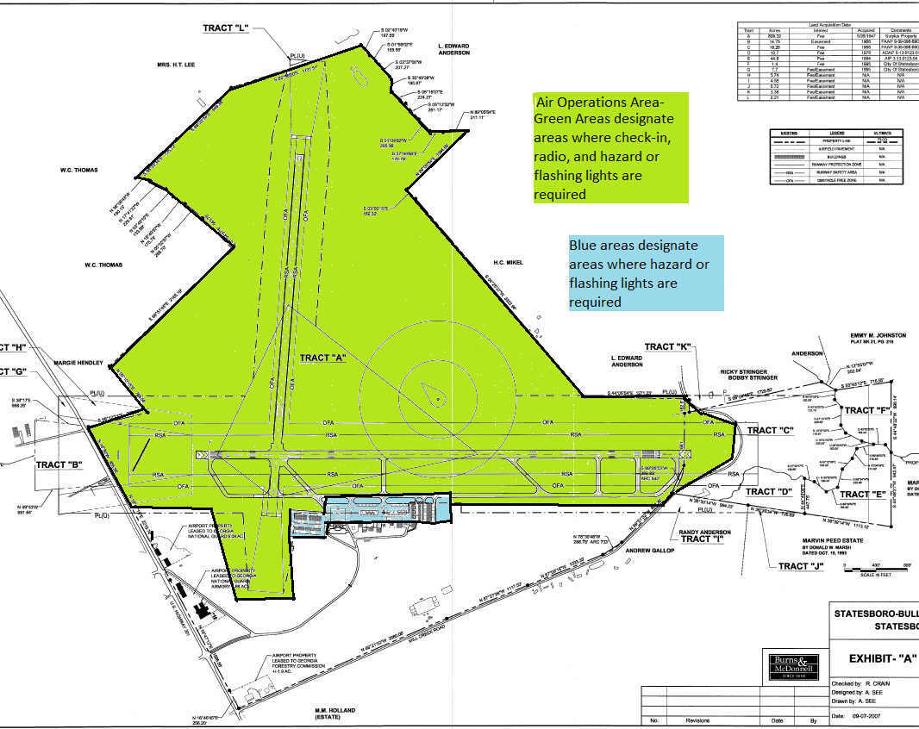

Exhibit B

